Article Summaries:

Seltzer and Anderson, The Dark Side of Numbers: The Role of Population Data Systems in Human Rights Abuses. (n.d.).

Summary: Article traces the history of censuses, quantified population metrics, and the ways they have been used in human rights abuses. Considers types of data at different scales (micro/meso/macro). Also includes potential methods to prevent abuses.

Key Quotes and Our Thoughts:
- 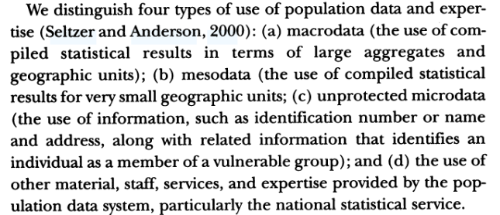(484)
  - I really find this macro/meso/micro data a useful divide. In human geography, we often think about data in similar ways. How does it work in other fields [opening question]?
- Draws on examples of Special Indian censuses, Japanese internment, forced migration in the Soviet Union, and the holocaust.
  - Thoughts to prompt discussion:
    - I think it's worth noting the widespread nature of this within “modernity” rather than just a simple authoritarian/fascist/communist/western blame—excessive focus on a single horrific example limits the scope of critique.
    - There’s an odd asymmetry in this, where the MOST repressive cases are never fully examined—Apartheid, USSR’s stranglehold in Eastern Europe, Japanese colonialism in North Korea, China’s Hukou system, etc.—it means our case studies are often close to home, which can be good—but might overemphasize the limitations of our own safeguards and ignore other abuses.
    - I think about this in the context of the “more than Tuskegee” reading—what blind spots do we open up when we always begin with one example?
- What was the motivation for human rights abuses? Less about a specific ideology, more about “bureaucratic opportunism and professional zeal” (494) See above.
- What safeguards can be put in place to prevent human rights abuses? [List from article]
  - Substantive—not gather data in the first place. Issue is that we don’t know what data will be used to oppress—the Khmer Rouge and “intellectuals.” And in France, they don’t have good counts of racial disparities because of the lack of racial statistics! Laicitie as a concept has the good and bad.
  - Methodological and technological safeguards—limit the microscale data access, anonymization at the smallest scales.
  - Organization and operational safeguards—decentralize data storage, have an independent committee control access, keep the “bridge” or “key” separate from the anonymized data.
  - Legal safeguards—legal provisions, though these safeguards are often ignored in times of crisis or states of exception. If the data is stored, then it is accessible, if a country is occupied by another, or a war might limit safeguards, or even a hostile administration.
  - Ethical safeguards—educate and agree on norms within professional communities.
- An additional point: “one of the reasons for adopting or revising a statement or code of ethical principles is the opportunity it provides for education and discussion” (499)
  - The act of discussion is important—perhaps more so than the specific standards! It's awareness! So what we’re doing here, in this ethics course itself! This stuff matters!

Carroll, S. R., Garba, I., Figueroa-Rodríguez, O. L., Holbrook, J., Lovett, R., Materechera, S., Parsons, M., Raseroka, K., Rodriguez-Lonebear, D., Rowe, R., Sara, R., Walker, J. D., Anderson, J., & Hudson, M. (2020). The CARE Principles for Indigenous Data Governance. Data Science Journal, 19, 43. https://doi.org/10.5334/dsj-2020-043

There is tension in Indigenous communities between protecting their rights over their data and supporting open data. This paper uses the CARE principles (which build upon FAIR) to manage data. The authors suggest using both CARE (Collective Benefit, Authority to Control, Responsibility, and Ethics) and FAIR (Findable, Accessible, Interoperable, Reusable).

Key Quotes and Our Thoughts:
- “Control, coupled with a focus on collective benefit and equity, repositions Indigenous Peoples, nations, and communities from being subjects of data that perpetuate unequal power distributions to self-determining users of data for development and wellbeing. Harnessing data for governance and acting in the governance of data, shifts Indigenous Peoples from invisibility within data ecosystems to vibrant contributors to data policies, practices, ethics, and innovation.” (2)
  - So rather than being the SUBJECTS of data, Indigenous Peoples can be contributors. Attempt to reverse the process of colonialism.
- “Ongoing processes of colonization of Indigenous Peoples and globalization of Western ideas, values, and lifestyles have resulted in epistemicide, the suppression and co-optation of Indigenous knowledges and data systems (Carroll, Rodriguez-Lonebear & Martinez 2019; Kukutai & Taylor 2016a; Kukutai & Walter 2015; Smith 2012). These processes have limited the ability of Indigenous Peoples to recover, develop, and sustain their knowledges, an ability that is central to Indigenous Peoples’ capacity to realize their human rights and fulfil their responsibilities (Wilson, 2004; Ratima 2001).” (2)
  - In other words, colonialism is ongoing and suppresses Indigenous knowledge production. Western values and epistemologies are privileged. [Does everyone know what epistemology is?]
- “Indigenous Peoples’ data comprise (1) information and knowledge about the environment, lands, skies, resources, and non-humans with which they have relations; (2) information about Indigenous persons such as administrative, census, health, social, commercial, and corporate and, (3) information and knowledge about Indigenous Peoples as collectives, including traditional and cultural information, oral histories, ancestral and clan knowledge, cultural sites, and stories, belongings.” (3)
  - Good definition, point to this.
- “For instance, data historically belonged to the researcher in mainstream settings, a notion that has shifted under open data and open science movements where publicly funded research requires data sharing. Meanwhile, Indigenous worldviews have typically centered ‘people’ and ‘purpose’ through governance processes that emphasize collective ownership and control of data” (3)
  - This is a good summary, but does sort of lump all Indigenous philosophies together. To be critical, this lens can also essentialize Indigeneity.
- 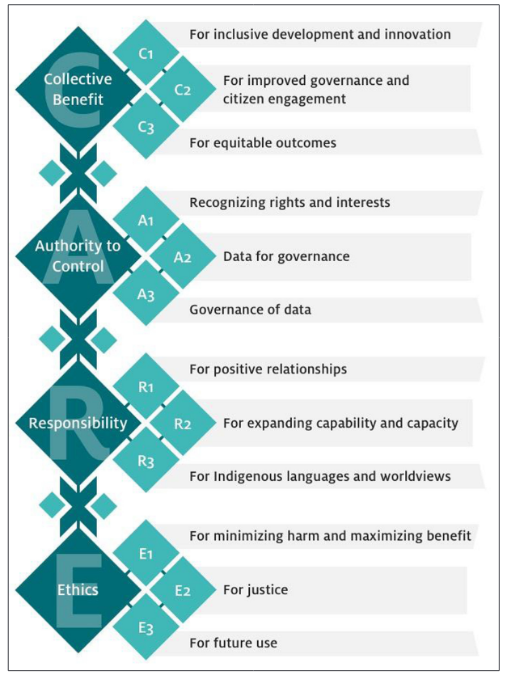 (Figure from Page 5)
- “As the mainstream community of data stakeholders advances standards and practices to facilitate data reuse and research reproducibility, the CARE Principles enhance that work by reversing historical power imbalances. The CARE Principles address historical inequities by creating value from Indigenous data in ways that are grounded in Indigenous worldviews and by realizing opportunities for Indigenous Peoples within the knowledge economy.” (8)
  - Summary of article with politically positive takeaway– why this matters.

Suchikova, Y., & Nazarovets, S. (2025). Extending the CARE Principles: Managing data for vulnerable communities in wartime and humanitarian crises. Scientific Data, 12(1), 420. https://doi.org/10.1038/s41597-025-04756-9

Summary: Basically an application of CARE (Collective Benefit, Authority to Control, Responsibility, Ethics) beyond Indigenous data, to the context of Ukrainian resistance to Russia’s invasion.

Key Quotes and Our Thoughts:
- “While initially focused on Indigenous data, CARE’s ethical imperatives can – and should – be extended to other vulnerable communities.” (1)
  - This article answers a question I had from the Carroll et al. (2020) article: Is CARE a set of principles for situations with a need for more comprehensive data protection, or marginalized populations on the whole, rather than only Indigenous groups? Suchikova and Nazarovets say, “yes.” Do we buy the idea that these principles “travel?”
- Defines “Collective benefit. The principle of collective benefit ensures that data collection and use actively contribute to community well-being.” (2)
  - I like the direction this article goes to further the use of CARE. But there might be a bit of a slippage here where we assume we know what “community well-being” means. From my liberal American perspective with ancestry from Ukraine, they’re facing a war of aggression and genocide– but Russia defines Ukraine as part of its “community” and thus Russia should get to have control over Ukrainian identity (which they argue doesn’t exist, see Putin’s “On the Historical Unity of Russians and Ukrainians”).
  - This is really the liberal-communitarian debate– but worth being aware of the large philosophical questions!
- “To safeguard the identities of faculty members who remain in occupied territories but continue teaching online, Ukrainian universities have deliberately hidden their personal profiles from public access13. Similarly, class schedules are withheld from public access to prevent sensitive operational details from being exploited.” (2)
  - The geography department at UW does this (my department). Engagement question: Does anyone else’s?
- “In occupied cities, open data initiatives must be carefully assessed against potential risks, as seemingly neutral datasets – such as economic indicators or migration statistics – can be repurposed for surveillance and repression.” (3)
  - This is probably the best argument against open data, and its very compelling for me. If the world itself were neutral, then we might be able to have purely open data—but the risk of harm is so great in some situations that it overrides the benefit of openness.

Questions for Discussion:

Seltzer and Anderson, The Dark Side of Numbers
- Consider the examples in this reading in the context of the “more than Tuskegee” reading—what blind spots do we open up when we focus on specific human rights abuses, rather than systems? Does this article have the same issues pointed out in “more than Tuskeegee?”
- The authors suggest that the motivation for the human rights abuses was more about “bureaucratic opportunism and professional zeal” (494), and less about a specific ideology. I think about this in the context of Arendt's "Banality of Evil." How does the primacy of "opportunism and zeal" complicate efforts to reduce these abuses? Or do we think the authors are wrong, and that actually there is more of an ideological motivation?
- Are the "Substantive" safeguards realistic-- i.e. don't gather some data in the first place? What limitations would exist if we refused to gather data? [prompt for Laicitie in France vis-a-vis insights from Critical Race Theory].
- From p. 499: “one of the reasons for adopting or revising a statement or code of ethical principles is the opportunity it provides for education and discussion." The act of discussion is important—perhaps more so than the specific standards? How do classes like this one help us be more ethical researchers?
- A more ontological question: Agree or disagree? p. 507: “We conclude with a simple point: numbers and the systems that produce them are morally neutral. It is what we - or others - do with them that counts.”

Carroll et al. (2020): Care Principles:
- The authors seem to make normative claims about the good of sharing data. Do marginalized communities have a duty to share data?
- On p. 3: “Indigenous Peoples’ data comprise (1) information and knowledge about the environment, lands, skies, resources, and non-humans with which they have relations; (2) information about Indigenous persons such as administrative, census, health, social, commercial, and corporate and, (3) information and knowledge about Indigenous Peoples as collectives, including traditional and cultural information, oral histories, ancestral and clan knowledge, cultural sites, and stories, belongings.”
  - Question: Is this definition too expansive to also allow for the suggested “increasing Indigenous Peoples’ participation in data governance” further down the page? In other words: every additional system to ensure equity may also increase the workload of overburdened scholars and institutions. How do we balance these demands?
- Somewhat of a critique: Can we really “create value” (page 8) out of data? Does this desire then push “western” ways of knowing onto indigenous understandings, sort of defeating the purpose?

Suchikova, Y., & Nazarovets, S. Extending CARE.
- Is this an appropriate use of CARE principles? Does the theory travel?
- One of these principles is (p. 2): "Collective benefit. The principle of collective benefit ensures that data collection and use actively contribute to community well-being.” How do we actually determine what counts as "community well-being," especially if the community is divided, or individual rights may be harmed for the "good" of the community?
- An example, p. 2: “To safeguard the identities of faculty members who remain in occupied territories but continue teaching online, Ukrainian universities have deliberately hidden their personal profiles from public access13. Similarly, class schedules are withheld from public access to prevent sensitive operational details from being exploited.”My department does this! Anyone else's?

Wilkinson et al, The FAIR Guiding Principles for scientific data management and stewardship
- Were you familiar with FAIR (and CARE) principles? If so, have you used them in your work? If not, can you think of ways you might implement them?
- Thoughts, in light of the Indigenous Data Governance reading, on Indigenous nations’ right to control their data, and any potential impacts?
- “…where the quality of the publication—and more importantly, the impact of the publication—is a function of its ability to be accurately and appropriately found, reused, and cited over time, by all stakeholders, both human and mechanical” and that “all research objects should be Findable, Accessible, Interoperable and Reusable (FAIR) both for machines and for people”.
  - To what extent do you agree or disagree? Is there additional context/information/clarifications that would inform your answer?
Carroll et al., Indigenous Data Governance: Strategies from United States Native Nations
- The authors define Indigenous data as “any facts, knowledge, or information about a Native nation and its tribal citizens, lands, resources, cultures, and communities. Information ranging from demographic profiles, to educational attainment rates, maps of sacred lands, songs, and social media activities”.
  - Does this align with your expectations/conceptualization of Indigenous data? [for example, it had not previously occurred to me to consider that all information (e.g. educational attainment rates), not just potentially sensitive information, would necessarily fall under that umbrella]
- Do you anticipate there being any unintended downstream effects of Indigenous folks’ data being separate/insular? Does this give you any pause, or are these considerations secondary/irrelevant to respecting autonomy, rightful ownership, etc.?
  - [example from reading: “If Indigenous data are not included in large datasets, such as genomics metadata, then Indigenous peoples will be invisible and may not realize the benefits of emerging health technologies and advances. On the other hand, if data about Indigenous peoples in big data and open data are used without guiding rights and interests frameworks, Indigenous peoples risk representation that reflects the bias in existing data ecosystems”]
Pittaway et al, ‘Stop Stealing Our Stories’: The Ethics of Research with Vulnerable Groups
- “…ethics cannot be limited to fulfilling the formal requirements of sponsoring institutions. Nor can it be confined to notions of ‘do no harm’. Ethics should be extended to promoting the interests and well-being of extremely vulnerable research subjects, in ways that make sense for the research subjects, as well as for researchers and their academic institutions and professional bodies. Thus it promotes an ethical understanding of subjects as participants in and beneficiaries of such research.”
  - To what extent do you agree or disagree? What responsibilities do researchers have to ascertain what ways of supporting their research participants “make sense” for them, and what parameters should be in place to guide how they go about this?

